CAPSTONE PROJECT REPORT
AI CRM & Sales Automation Platform
AI Sales Development Representative (SDR) using n8n and AI

Submitted By
Name: Naman Pratap Singh
Course/Program: AI (LLMs, GenAI)
GitHub: ______________________________

Summer School'26 — OpenAI Agents SDK Capstone Project

Technology Stack
- n8n — workflow automation and orchestration
- AI / LLM API — lead qualification, scoring and sales decision support
- n8n Form Trigger — lead/customer data collection
- Google Sheets — centralized CRM database and persistent lead memory
- Gmail — automated sales outreach and follow-up communication
- Google Calendar / scheduling integration — meeting or follow-up scheduling where configured
- JavaScript — data transformation and business logic
- HTTP Request / REST APIs — external service integration
________________________________________________________________________________

1. Abstract
The AI CRM & Sales Automation Platform is an AI-powered workflow automation solution designed to simplify and automate the lead management and sales development process. Traditional sales development requires sales teams to manually collect lead information, enter records into a CRM, evaluate lead quality, send personalised emails, monitor follow-ups and identify high-priority prospects.
The proposed system uses n8n as the central workflow automation platform and integrates AI to analyse lead information and generate an AI Score and Lead Category. Google Sheets acts as the centralized CRM database and persistent memory, while Gmail is used for automated outreach and follow-up communication.
The system is divided into modular workflows. A lead is collected and stored, qualified using AI, contacted through automated outreach, monitored for follow-up activity, and routed to sales when its qualification state requires attention. The modular design also allows the workflows to be exposed as sub-workflows and combined into a single master demonstration workflow.
The project is based on the AI Sales Development Representative problem statement from the capstone brief, which asks for company/lead research, lead qualification, personalised outreach, meeting coordination and CRM updates, together with agent handoffs, tools/APIs, memory/context management, structured outputs and human approval where applicable.

2. Introduction
Sales teams receive leads from forms, websites, professional networks and other channels. Each lead may contain different requirements, budgets, timelines, company information and contact details. Processing these requests manually can create delays and inconsistent follow-up.
The AI CRM & Sales Automation Platform addresses this problem by automating the complete lead-to-sales pipeline. Instead of manually reviewing every lead and updating every CRM field, the salesperson provides or receives lead information and the system automatically prepares the record, applies AI-based qualification, communicates with the prospect, tracks follow-up state and highlights leads that need sales attention.
The system therefore combines AI decision-making, business rules, cloud services and workflow automation into an end-to-end sales operations solution.

3. Problem Analysis

3.1 Business Context
Sales development representatives frequently perform repetitive operations for every prospect. The same information may need to be entered into a CRM, evaluated for sales fit, used to write an email, checked again after several days and routed to a salesperson if the opportunity becomes important.
For example, a sales representative may need to:
- Receive and read the lead request.
- Check contact and company information.
- Understand the business requirement.
- Estimate the lead's potential and priority.
- Assign a lead category.
- Prepare and send a personalised outreach email.
- Track the last and next follow-up.
- Check inactive leads.
- Escalate high-priority leads to sales.
- Update the CRM after every action.
This repetitive process consumes time and can lead to missed follow-ups, inconsistent qualification and incomplete CRM records. Automation can reduce these problems and make the process more consistent.

4. Stakeholders

4.1 Prospects / Leads
Prospects provide their contact and business requirements and receive personalised sales communication.

4.2 Sales Representatives
Sales representatives use the AI-generated score and category to prioritise their work and receive escalations for important leads.

4.3 Sales Manager
The sales manager can monitor lead quality, follow-up activity and the overall state of the CRM.

4.4 System Administrator
The administrator manages n8n workflows, credentials, integrations, execution history, data storage and error monitoring.

4.5 Business / Organisation
The organisation benefits from reduced manual work, faster responses, better CRM consistency and scalable sales operations.

5. Existing Pain Points

5.1 Manual Lead Processing
Sales teams repeatedly enter and review the same lead information.

5.2 Time Consumption
Qualification, outreach and follow-up require repeated manual effort.

5.3 Repetitive Work
Similar tasks are performed for every new prospect.

5.4 Data Management
Lead information may become inconsistent when stored or updated manually.

5.5 Inconsistent Qualification
Different sales representatives may prioritise similar leads differently.

5.6 Missed Follow-ups
Leads can be forgotten when follow-up depends entirely on manual reminders.

5.7 Communication Delays
Preparing and sending personalised messages manually can slow the sales process.

5.8 Lack of Centralised State
Without a persistent CRM record, later automation cannot easily determine what has already happened.

6. Project Objectives
The primary objective is to build an automated AI-powered sales development and CRM system.
- Collect lead information automatically.
- Create and maintain a centralised lead record in Google Sheets.
- Generate a unique Lead ID.
- Use AI to analyse lead requirements and produce an AI Score.
- Assign a Lead Category such as Cold, Warm or Hot.
- Generate and send personalised sales communication.
- Track Status, Last Follow-up and Next Follow-up.
- Detect leads requiring follow-up or sales attention.
- Use existing qualification results for downstream sales decisions.
- Reduce repetitive manual CRM work.
- Use conditional branching for sales decisions.
- Provide a human approval point for critical actions where required.
- Maintain an audit trail through CRM records and n8n execution history.
- Combine independent workflows as sub-workflows for an end-to-end demonstration.

7. Proposed Solution
The proposed system consists of modular n8n workflows connected through structured CRM data. Each workflow has a specific responsibility and passes the resulting lead context to the next stage.
Lead Input
↓
Lead Registration
↓
AI Qualification
↓
Personalised Outreach
↓
Follow-up Monitoring
↓
Sales Priority / Escalation
↓
Final CRM State
Google Sheets acts as the shared memory layer. The same Lead ID and structured fields are used to identify and update a lead throughout the complete lifecycle.

8. System Architecture
The system uses n8n as the central automation layer. Lead information enters through an input trigger, AI processes the business information, Google Sheets stores the persistent state, and Gmail performs communication. Conditional IF nodes control whether a lead continues through a normal path or a priority/escalation path.
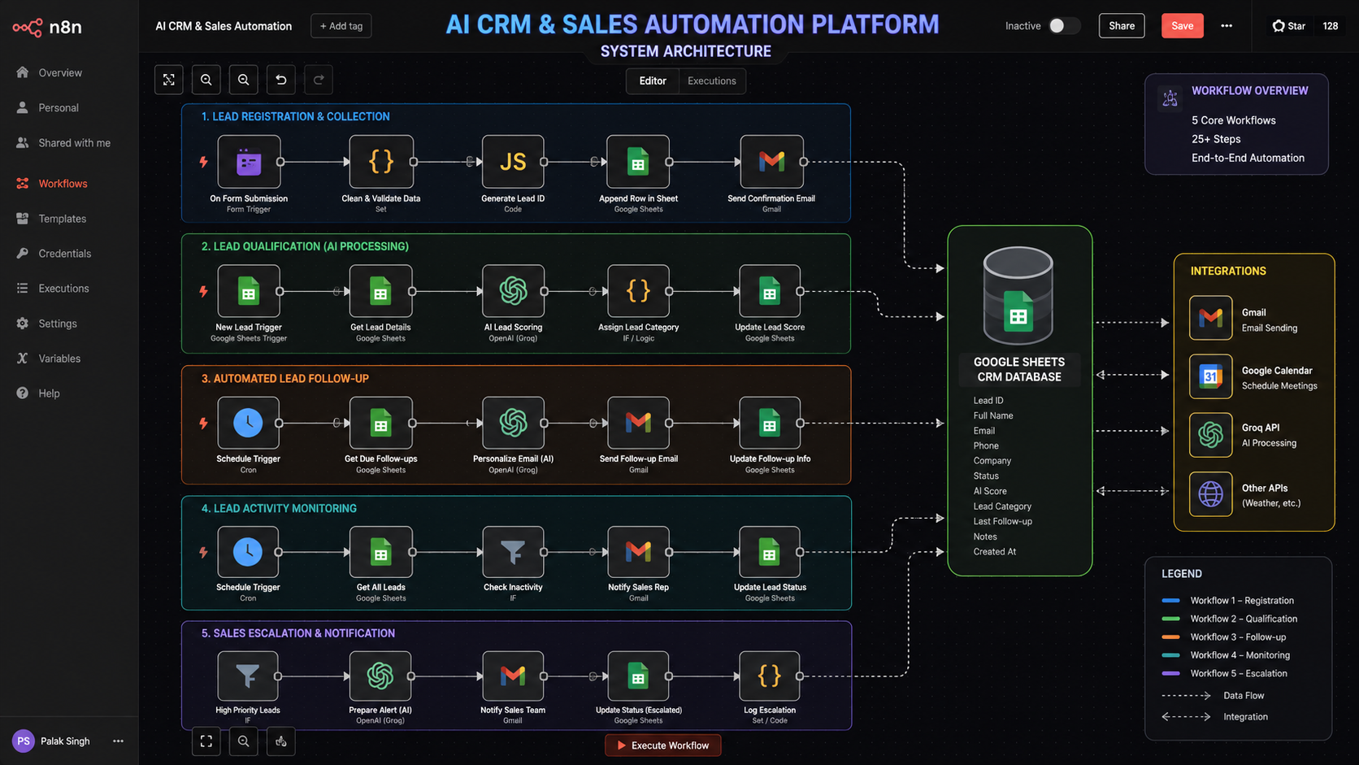

AI CRM & SALES AUTOMATION ARCHITECTURE DIAGRAM

9. Workflow Architecture
The project is divided into six major independent workflows. Workflows 1–5 form the lead-management lifecycle, while Workflow 6 generates a scheduled weekly sales performance report. This structure keeps the system modular and allows each responsibility to be tested separately. For the final demo, Workflows 1–5 can be exposed as sub-workflows and called sequentially from a master workflow; Workflow 6 can run independently on its weekly schedule.

Workflow 1 — Lead Registration
↓
Workflow 2 — AI Lead Qualification
↓
Workflow 3 — Automated Outreach & Follow-up
↓
Workflow 4 — Activity Monitoring
↓
Workflow 5 — Sales Priority & Escalation
↓

Workflow 6 — Sales Performance Report

10. Detailed Workflow Descriptions

Workflow 1 — Lead Registration

Purpose
Collect and store the prospect's sales requirements in the central CRM.
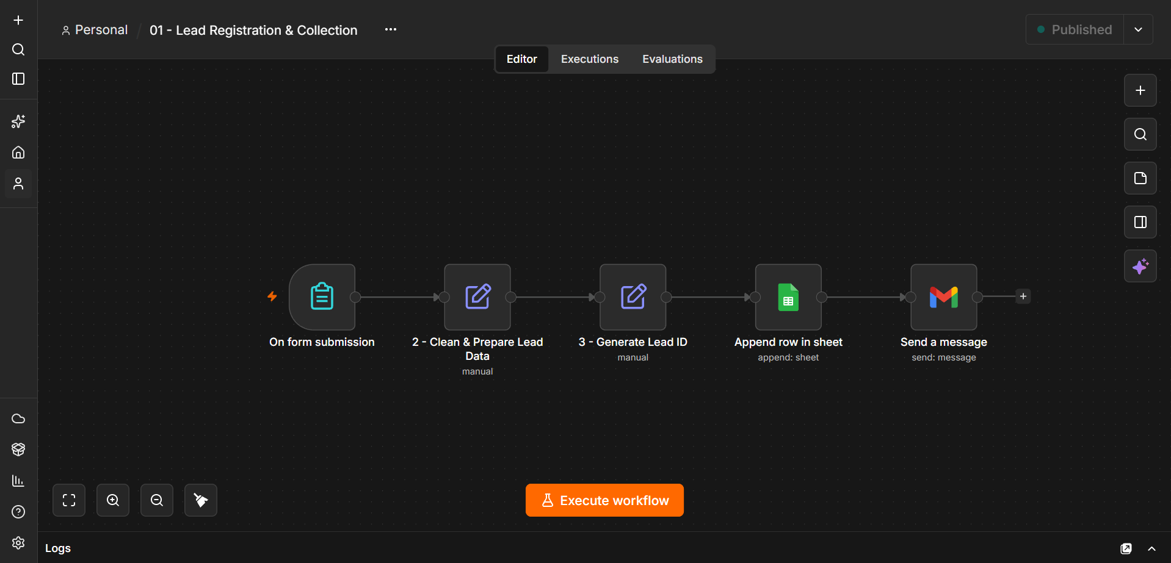

LEAD REGISTRATION

Input Data
The lead record can contain:
- Lead ID
- Full Name
- Email
- Phone Number
- Company Name
- Business Requirement
- Lead Source
- Estimated Budget
- Expected Timeline
- Status
- Submitted At

Processing
- A lead is received through the configured input trigger.
- Lead information is cleaned and prepared into a consistent structure.
- A unique Lead ID is generated.
- The lead is appended to the Leads sheet.
- The initial status and submission timestamp are stored.
- The record becomes available for the qualification workflow.

Output
A persistent lead record is created in Google Sheets. This record becomes the shared context for subsequent workflows.

Workflow 2 — AI Lead Qualification

Purpose
Analyse the lead's business information and convert it into a structured qualification result that can be used by downstream sales automation.

Flow
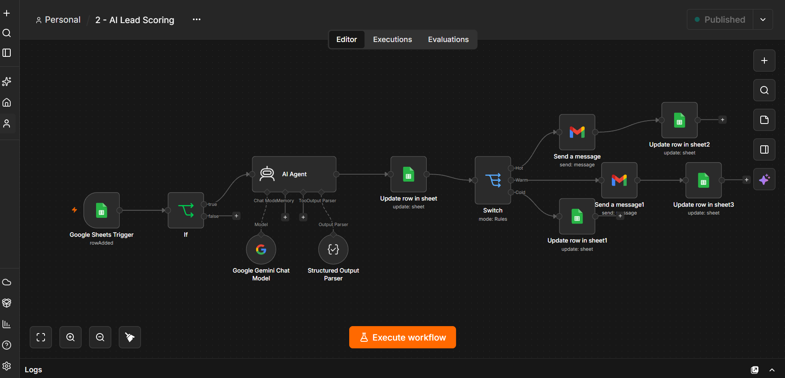

AI LEAD SCORING

AI Decision Making
The AI qualification stage can consider:
- Business requirement
- Estimated budget
- Expected timeline
- Company context
- Lead source
- Potential sales fit
The AI produces an AI Score and a Lead Category. A typical category structure is Cold, Warm and Hot. The exact scoring boundaries should match the scoring logic implemented in the n8n workflow.

Example Output
Field | Example | Meaning
AI Score | 85 | Numerical qualification / priority signal
Lead Category | Hot | High-priority sales lead
Status | Qualified | Current CRM state, depending on implementation

Important Design Rule
Once the AI qualification workflow has already assigned Lead Category, later workflows should consume that stored category rather than recalculating the same classification. For example, the sales escalation workflow can simply test whether Lead Category equals Hot.

Workflow 3 — Automated Outreach & Follow-up

Purpose
Use the qualified lead information to send personalised sales communication and record the communication state.

Flow
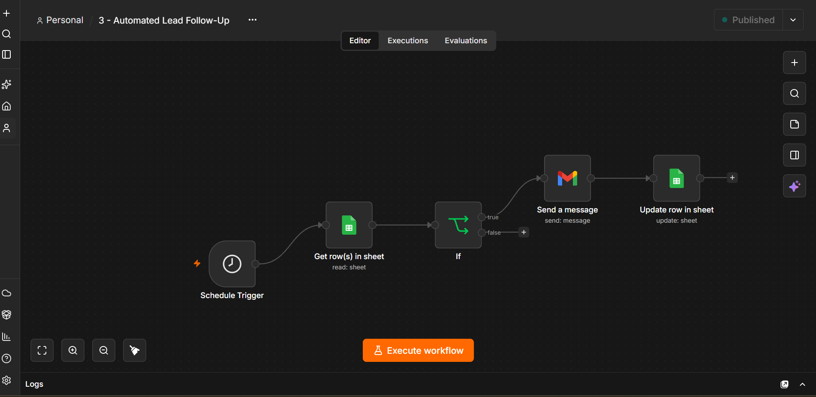

AUTOMATED LEAD FOLLOW UP

Processing
- Retrieve the lead from Google Sheets.
- Check the current Status and follow-up state.
- Prepare the personalised email using lead fields.
- Send the message through Gmail.
- Update Status to indicate that follow-up/outreach was sent.
- Store Last Follow-up and calculate/store Next Follow-up.

Follow-up Memory
- Status — describes the current communication state.
- Last Follow-up — records when the latest follow-up was sent.
- Next Follow-up — stores when the next action is expected.
For production use, the workflow can run on a Schedule Trigger. For the demo video, the interval can be temporarily shortened so the result is visible during the recording.

Workflow 4 — Activity Monitoring

Purpose
Monitor CRM records and identify leads that require another sales action because the expected follow-up period has passed.

Flow
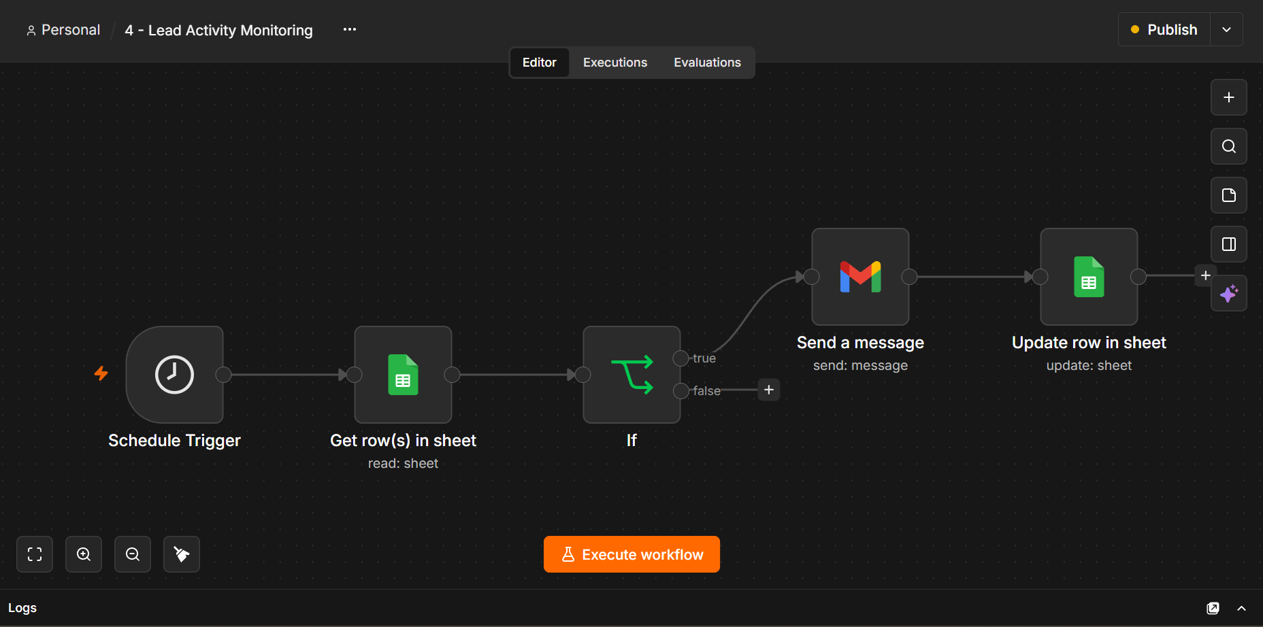

LEAD ACTIVITY MONITORING

Conditional Decision
The workflow reads CRM records and uses an IF condition to determine whether a lead matches the configured follow-up rule.
Status = "Follow-up Sent"
AND
Last Follow-up is older than the configured inactivity period
A seven-day inactivity period can be used for the production concept. During a demonstration, the timestamp or interval can be adjusted so the TRUE branch can be shown without waiting several days.

Why the TRUE Branch May Not Execute
- The Status value does not exactly match the expected value.
- Last Follow-up is newer than the configured threshold.
- Last Follow-up is empty or cannot be parsed as a date.
- The previous node has not been executed, so the IF node is using stale preview data.
- The workflow is intentionally using a production interval while the demo expects an immediate result.

Workflow 5 — Sales Priority & Escalation

Purpose
Use the qualification already stored in the CRM to decide whether a lead requires a high-priority sales action.

Flow
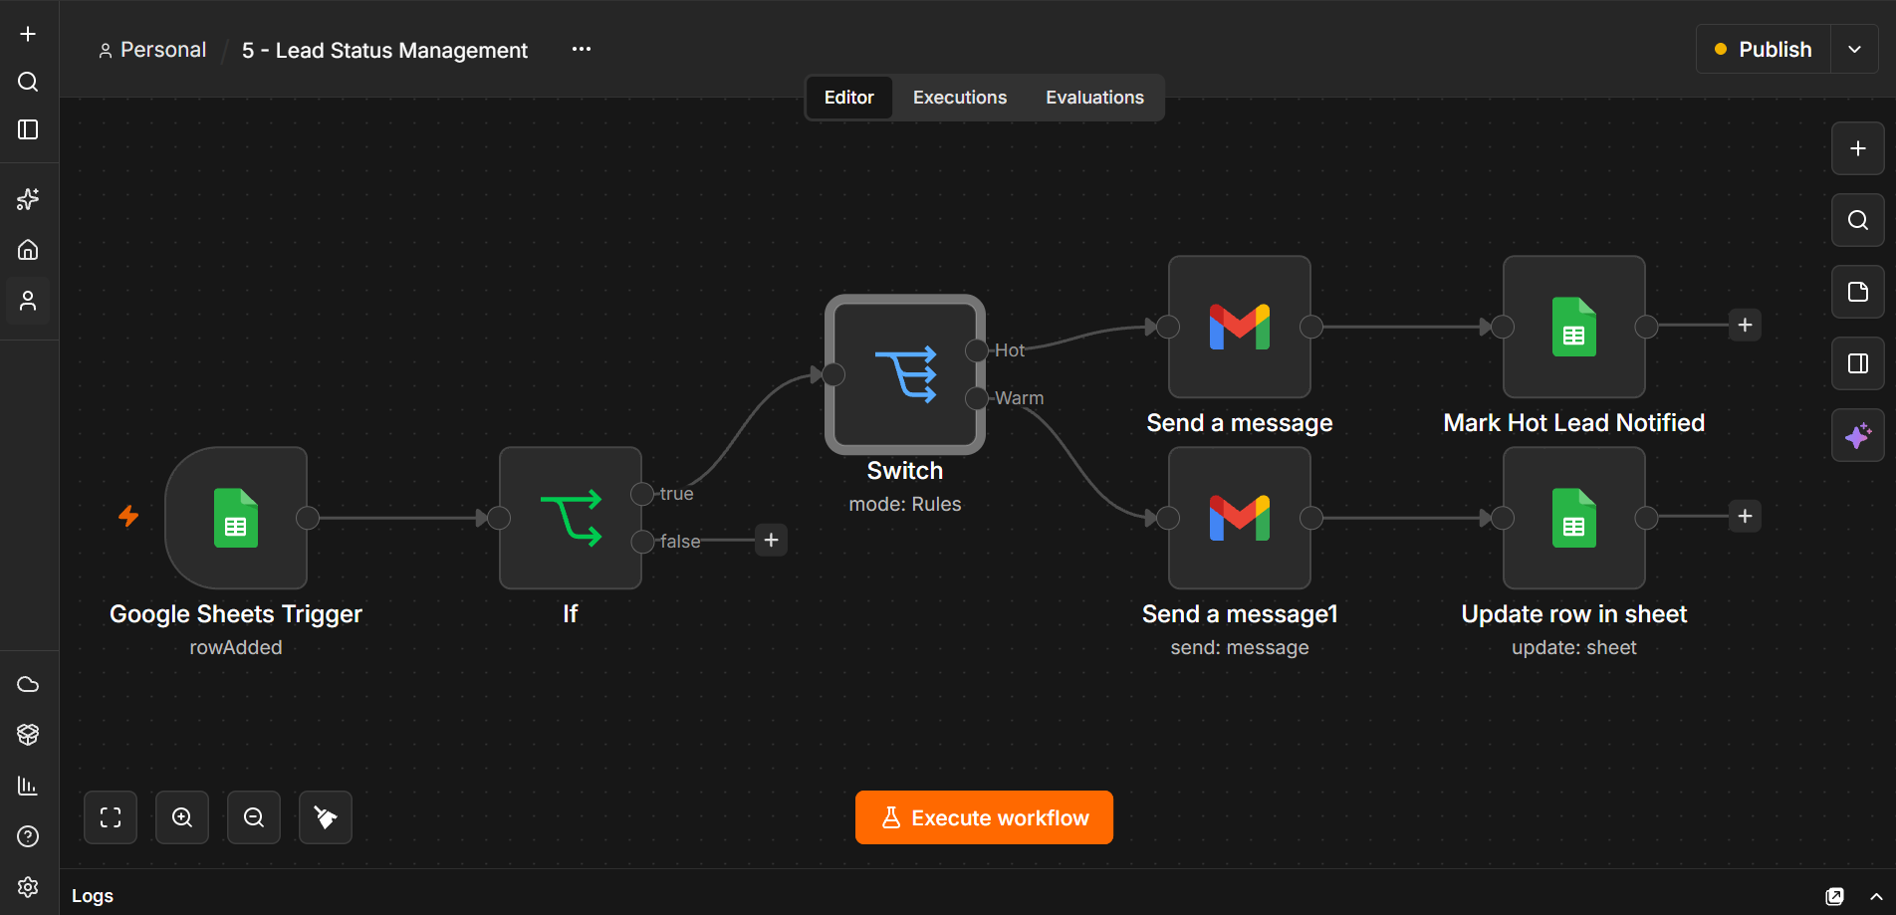

LEAD STATUS MANAGEMENT

Decision Logic
A simple example is:
Lead Category = "Hot" ?
YES → Sales notification / escalation
NO → Continue normal sales flow

Important Design Rule
If Workflow 2 has already assigned the Lead Category, Workflow 5 should not run the same AI qualification again. It should consume the existing structured decision. This prevents duplicated AI work and makes the agent/workflow handoff clearer.

Human Approval
Where the final action is considered critical, the system can pause for a sales representative or manager to approve the proposed escalation or external action before it is executed.

Workflow 6 — Sales Performance Report

Purpose
Generate a weekly sales performance report from the CRM data and deliver it to the sales department.

Flow
The workflow combines a weekly Schedule Trigger, Google Sheets data retrieval, report generation, and Gmail delivery.
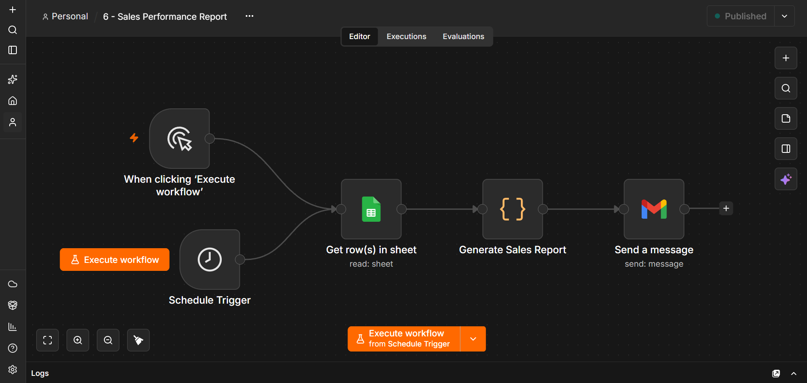

Processing
• The Schedule Trigger starts the workflow on the configured weekly schedule.
• The Google Sheets node retrieves the current CRM records.
• The Code node generates the sales performance report from the retrieved data.
• The Gmail node sends the completed report to the sales department.

Output
A weekly sales performance report is generated from the CRM records and sent to the sales department by email.

11. n8n Nodes Used
The project uses multiple n8n nodes and integrations.
Node / Integration | Purpose
Form Trigger / Manual Trigger | Collect or start a lead-processing request
Google Sheets | Store and retrieve CRM lead records
Edit Fields / Set | Format and prepare lead data
IF | Conditional decision-making
HTTP Request | Communicate with external APIs
AI / LLM Node or HTTP AI API | Lead qualification and AI decision support
Code | JavaScript data processing and transformation
Gmail | Send personalised sales messages and notifications
Google Calendar / Scheduler | Schedule meetings or follow-up events where configured
Merge | Combine data from different branches when required
Schedule Trigger | Periodic follow-up and monitoring
Execute Sub-workflow | Connect independent workflows in the master demonstration
The final implementation may contain 20+ nodes across the independent workflows depending on the exact AI, Gmail, Google Sheets and scheduling configuration.

12. AI Implementation
AI is one of the core components of the project. It is used to interpret business requirements and assist sales prioritisation rather than merely moving data between nodes.

12.1 Lead Qualification
AI analyses the available lead information and produces a structured qualification result, including an AI Score and Lead Category.

12.2 Sales Decision Support
The AI-generated qualification result becomes context for downstream sales workflows. The later workflow can make a deterministic decision from the stored category.

12.3 Personalised Outreach
Lead information can be inserted into an email-generation prompt or message template so that the outreach reflects the prospect's business requirement and company context.

12.4 Agent-Oriented Design
To satisfy the capstone's multi-agent requirement, the final implementation should expose specialised AI responsibilities rather than treating every n8n node as an agent. A suitable logical mapping is:
Specialised AI Role | Responsibility
Prospect / Lead Research Agent | Understand and enrich the prospect/business context.
Lead Qualification Agent | Evaluate fit, score the lead and assign category.
Outreach Agent | Create personalised sales communication.
Follow-up / Sales Activity Agent | Use interaction context to recommend the next sales action.
Sales / CRM Agent | Coordinate CRM updates, priority routing and sales handoff.

13. Conditional Branching
The project uses n8n IF nodes to make automated decisions. These conditions should use structured CRM fields rather than repeating AI work whenever a previous workflow has already produced the required decision.
Example 1 — Lead Priority:
Lead Category = "Hot"
↓
YES NO
↓ ↓
Sales Alert Normal Flow
Example 2 — Follow-up Monitoring:
Status = Follow-up Sent
AND
Last Follow-up older than threshold
Conditional branching allows the platform to behave differently depending on the lead's current CRM state.

14. External API / Service Integration
The system communicates with external services through n8n integrations and HTTP requests where required.
Service | Purpose
AI / LLM API | Lead qualification, scoring, sales decision support and/or email generation
Google Sheets API | Central CRM storage and persistent lead state
Gmail API | Automated outreach, follow-up and sales notifications
Google Calendar API | Meeting/follow-up scheduling where configured
REST / HTTP APIs | Additional company or prospect intelligence services where configured

15. Google Sheets Integration
Google Sheets acts as the central CRM database and shared memory layer. The same lead record is updated throughout the workflow lifecycle.
Field | Description
Lead ID | Unique identifier for the lead
Full Name | Prospect name
Email | Prospect email
Phone Number | Prospect contact number
Company Name | Organisation/company
Business Requirement | Lead's requirement or request
Lead Source | Origin of the lead
Estimated Budget | Potential budget
Expected Timeline | Expected purchase/implementation timeline
Status | Current CRM communication state
Submitted At | Time the lead entered the system
AI Score | AI-generated qualification score
Lead Category | Cold / Warm / Hot or configured category
Sales Representative | Assigned sales owner, if used
Last Follow-up | Timestamp of latest follow-up
Next Follow-up | Timestamp for next expected action
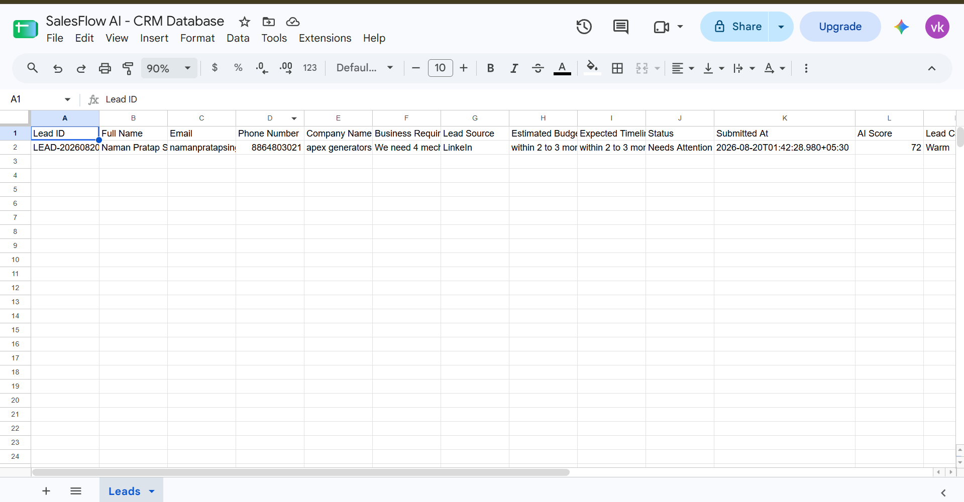
GOOGLE SHEET - SalesFlow AI

16. Gmail Automation
Gmail is used to automatically communicate with prospects and, where required, notify the sales team.

16.1 Outreach Email
The message can contain:
- Prospect name
- Company name
- Business requirement
- Personalised sales message
- Next step / call-to-action
- Sales contact information

16.2 Follow-up Email
When the follow-up condition becomes true, the workflow can send a follow-up message and update the CRM with the Last Follow-up and Next Follow-up values.
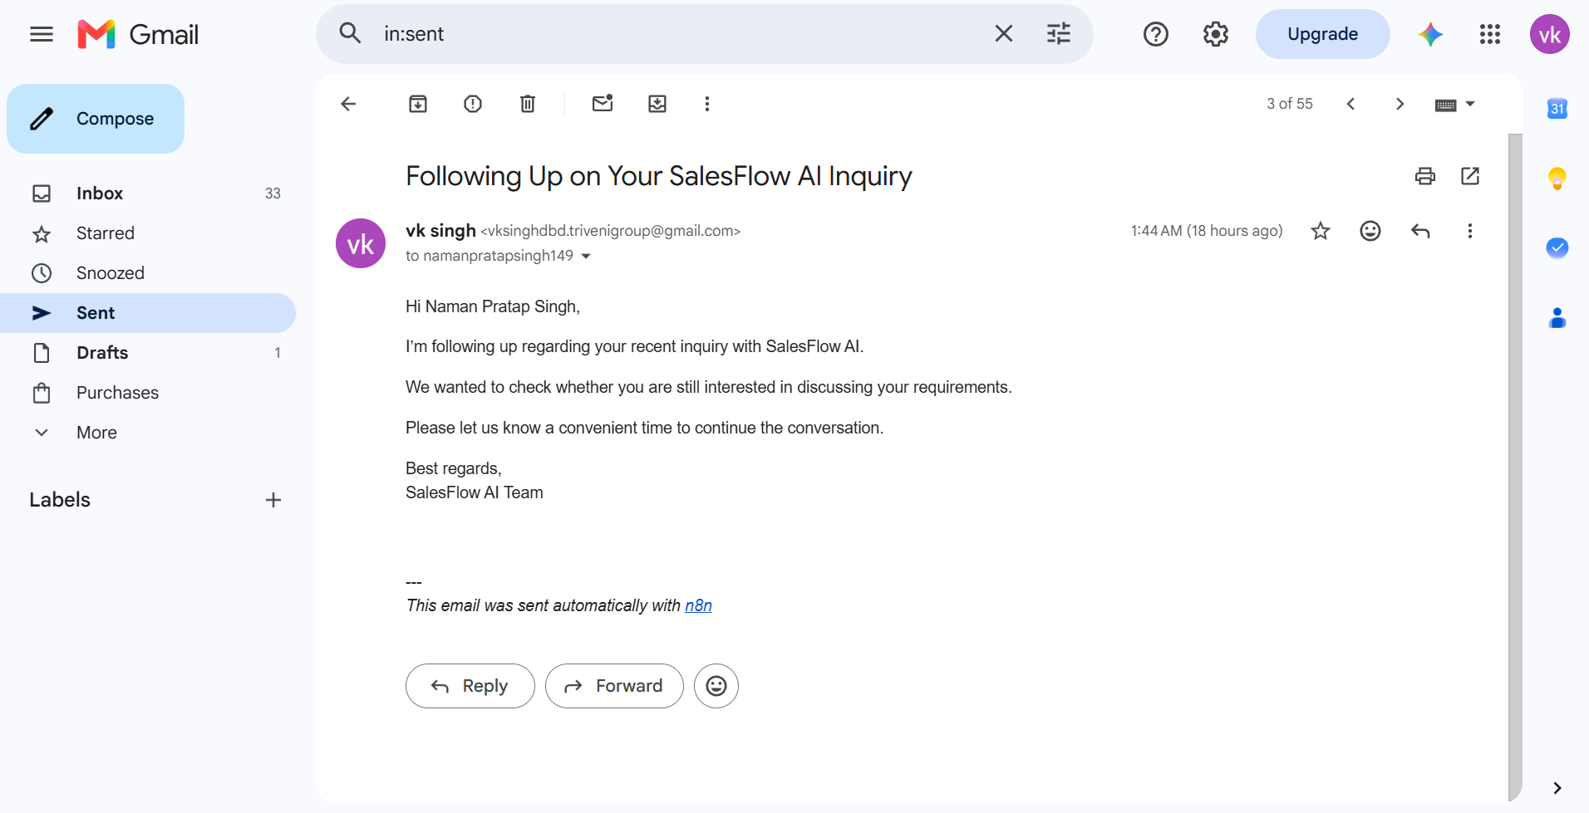

17. Sample Output
A typical completed CRM record may contain a lead similar to the following structure:
Field | Example
Lead ID | LEAD-20260820-001207
Full Name | Naman Pratap Singh
Company Name | Sharma's Bakery
Business Requirement | Hiring 3 skilled bakers with good communication
Lead Source | LinkedIn
Estimated Budget | Within 2–3 months / configured budget
Expected Timeline | Within 2 to 3 months
AI Score | 58 or another AI-generated score
Lead Category | Warm
Status | Follow-up Sent
Last Follow-up | Recorded timestamp
Next Follow-up | Recorded next-action timestamp
The values above illustrate the structure of the current CRM implementation; the actual values change for each lead.

18. Advanced Features

18.1 AI-Powered Decision Making
AI analyses lead requirements and generates a qualification score/category that supports sales prioritisation.
Status: Implemented / to be verified against final AI agent implementation.

18.2 Human Approval
A human approval stage can be placed before a critical sales action such as a high-priority escalation or sensitive external communication.
Purpose: Prevent an incorrect automated decision from being immediately finalised.

18.3 Conditional Branching
IF nodes are used to evaluate lead status, qualification category and follow-up timing.

18.4 Error Handling
The workflow can detect failed API calls, missing CRM fields, invalid timestamps, failed email delivery or AI service failures.

18.5 Logging and Audit Trail
Google Sheets maintains the lead state while n8n execution history provides an additional execution audit trail.

18.6 Scheduled Workflow
Schedule Trigger can periodically check follow-up timestamps and identify leads that require another action. Workflow 6 also uses a Schedule Trigger for weekly sales performance reporting.

19. Error Handling Strategy
The system should handle errors at multiple stages.

19.1 API Error
API Request
↓
Error?
↓
YES → Log / Retry / Fallback
NO → Continue

19.2 Invalid Lead Data
If required fields such as Email or Lead ID are missing, the workflow should stop or route the record for correction instead of sending an invalid message.

19.3 AI Failure
If the AI service fails, the workflow can log the error, retry the operation or route the lead for manual processing.

19.4 Follow-up Data Error
If Last Follow-up is missing or cannot be parsed, the monitoring condition should fail safely instead of incorrectly triggering an escalation.

20. Data Flow
In parallel, Workflow 6 reads the CRM data on its weekly schedule, generates a sales performance report, and sends the report to the sales department.
Lead Input
↓
Form / Trigger
↓
Lead Record
↓
Google Sheets
↓
AI Qualification
↓
AI Score + Lead Category
↓
Outreach
↓
Follow-up Monitoring
↓
Sales Priority / Escalation
↓
Final CRM State
↓
Google Sheets + Gmail

21. Workflow Interaction
The workflows communicate through the shared customer/lead record.
- Workflow 1 creates the initial lead record.
- Workflow 2 reads the lead and determines AI Score and Lead Category.
- Workflow 3 uses the lead context and qualification state to perform outreach/follow-up.
- Workflow 4 reads the communication timestamps and detects inactivity.
42. Workflow 6 reads CRM data on a weekly schedule, generates a sales performance report, and sends it to the sales department.
- Workflow 5 uses the stored Lead Category to route high-priority sales actions.
- The master workflow can call the individual workflows as sub-workflows for a controlled end-to-end demonstration.

22. Benefits

For Sales Teams
- Reduced repetitive CRM work
- Faster lead qualification
- Consistent lead prioritisation
- Automated outreach and follow-up
- Better visibility of inactive leads
- Priority routing for important opportunities

For Sales Managers
- Centralised lead records
- Structured AI scoring
- Improved follow-up visibility
- Execution/audit history

For Prospects
- Faster responses
- More personalised communication
- More consistent follow-up

23. Deliverables
- n8n workflow JSON files for the individual workflows.
- Detailed project documentation.
- System architecture diagram.
- Master/sub-workflow demonstration.
- 5–10 minute demo video.
- GitHub repository containing README, workflow JSON files, screenshots, architecture and setup instructions.
- 10–12 slide presentation.
The capstone brief specifically asks for complete source code, an agent architecture diagram, project documentation, a GitHub repository with README, a 5–10 minute demo video and a 10–12 slide presentation.

24. Final Submission Checklist
- All workflow screenshots inserted into the blank figure spaces.
- Final system architecture diagram inserted.
- Six workflow canvases clearly shown.
- Master/sub-workflow canvas shown.
- Google Sheets final CRM screenshot inserted.
- Gmail automation screenshot inserted.
- AI Score and Lead Category output demonstrated.
- TRUE branch of follow-up monitoring demonstrated.
- Hot lead escalation demonstrated.
- At least five specialised AI agent responsibilities implemented in the final code.
- At least five tools/APIs clearly documented.
- Agent handoffs clearly demonstrated.
- Persistent CRM memory/context demonstrated.
- Structured outputs documented.
- Human approval implemented where applicable.
- Error handling and logging demonstrated/documented.
- GitHub repository prepared.
- 5–10 minute demo video recorded.
- 10–12 slide presentation prepared.

25. Conclusion
The AI CRM & Sales Automation Platform demonstrates how AI, cloud applications and workflow automation can be combined to solve a practical sales problem. The system transforms a raw lead into a structured CRM record, uses AI to determine sales priority, automates personalised communication, monitors follow-up activity and routes important leads to the sales team.
n8n acts as the central automation and orchestration layer, Google Sheets provides persistent CRM memory, Gmail provides communication, and AI provides intelligent qualification and decision support. The modular workflow design also makes the project easier to test, explain and demonstrate.
For the final capstone implementation, the workflow layer should be paired with genuine specialised AI agents, clear agent handoffs, structured outputs, tool integrations, shared context and human approval where required. This creates an end-to-end AI SDR system that is suitable for demonstrating the capabilities requested in the Summer School'26 capstone project.

Project Summary
Item | Details
Project | AI CRM & Sales Automation Platform
Domain | Sales / AI SDR
Automation Platform | n8n
AI | AI / LLM-based lead qualification and sales decision support
CRM / Memory | Google Sheets
Communication | Gmail
Scheduling | Google Calendar / Schedule Trigger where configured
Programming | JavaScript
Architecture | Modular, API-driven, AI-powered workflow automation

